CF Margarita Run
May 5th
- Race swag to the first 200 registered
- Prizes to top male & female finishers & top 3 in 10 year age groups
- All proceeds benefit Cystic Fibrosis charities
- Post Race Celebration featuring TRILOGY, a basket auction & local food trucks!!!
- 6:30pm Race Start
- 5:30pm Race Registration
- Race begins at Pavilion Fire Department
- $20 preregister/$25 race day
- Approximate 5.5K distance

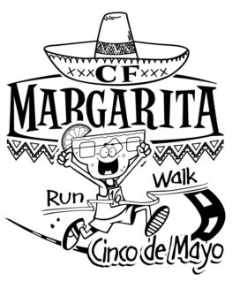

www.cfteamnatalie.com
www.facebook.com/cfmargaritarunny

Please make all checks payable to the Cystic Fibrosis Foundation and mail to: Team Natalie, 1349 Bank Street Rd., Wyoming, NY 14591.
LAST NAME FIRST NAME
NUMBER AND STREET
TOWN/CITY STATE ZIP
EMAIL
PHONE NUMBER GENDER M F AGE (ON RACE DAY)

I know that participating in such event is a potentially hazardous activity. l should not enter and walk/run unless I am medically able and properly trained. I agree to abide by the decision of the walk/run officials relative to my ability to safely complete the event. I understand that there is no road control for these events and that I am responsible for being mindful of traffic. I assume all risks associated with running/walking this event including, but not limited to, falls, contact with other runners, the effects of the weather, including high heat and/or humidity and the conditions of the course, all such risks being known and appreciated by me. I grant permission to the organizing groups to use any photograph, motion pictures, or recordings of my taking part in this event for any legitimate purpose. Having read this waiver acknowledging these facts and in consideration of you accepting my entry, I for myself, and everyone entitled to act on my behalf, waive and release all Volunteers and Employees, the Counties of Wyoming and Genesee, the Towns of Covington and Pavilion, the Pavilion Volunteer Fire Department, and any and all race organizers, sponsors and beneficiaries from any claims or liabilities of any kind arising out of my participation in this event. I understand that all entry fees are nonrefundable.
I have read this waiver and certify my compliance and agreement with its content with my signature.
(Signature)____________________________________________________________________ (Date)_________________________
(Parent/Guardian Signature- if under 18) _________________________________________________ (Date)_________________________

